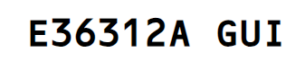

### **GUI Diagram**

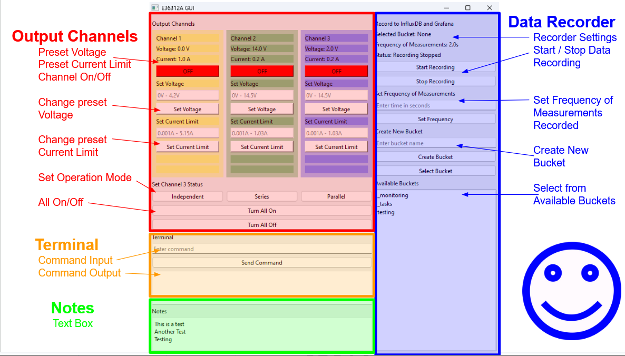

### **Output Channels**

| **Heading** | **Description** |
| --- | --- |
| **Preset Voltage** | Displays the voltage to which it has been set |
| **Preset Current** | Displays the current limit to which it has been set |
| **Channel On/Off** | Toggles each individual channel |
| **Change Preset Voltage** | Changes the preset voltage for each channel |
| **Change Preset Current Limit** | Changes the preset current limit for each channel |
| **Set Operation Mode** | Sets the output mode of Channel 3 to independent, series, or parallel |
| **All On/Off** | Toggles all channels |

### 

### **Terminal**

| **Heading** | **Description** |
| --- | --- |
| **Command Input** | Users can enter commands not covered by the GUI |
| **Command Output** | The result of the command input is displayed here |

### 

### **Notes**

| **Heading** | **Description** |
| --- | --- |
| **Text Box** | Users can type notes about miscellaneous commands or observations.  These notes are autosaved to a text file. |

### **Data Record**

| **Heading** | **Description** |
| --- | --- |
| **Recorder Settings** | Displays the bucket that will store the data, the frequency of measurements and whether the program is currently recording. |
| **Start/Stop Data Recording** | Toggles whether the data is saved and uploaded to the database. Recorder only records data for channels that are ON. |
| **Set frequency of measurements recorded** | Sets the delay between each measurement taken by the program. 2 seconds is the lowest due to the execution time of the code. |
| **Create new bucket** | Creates a new bucket in InfluxDB that can be written to. Bucket never expires |
| **Select from available buckets** | Displays all available buckets that can be written to by the program |

### **Programming Diagram**

#### Functions

### 

#### Layouts

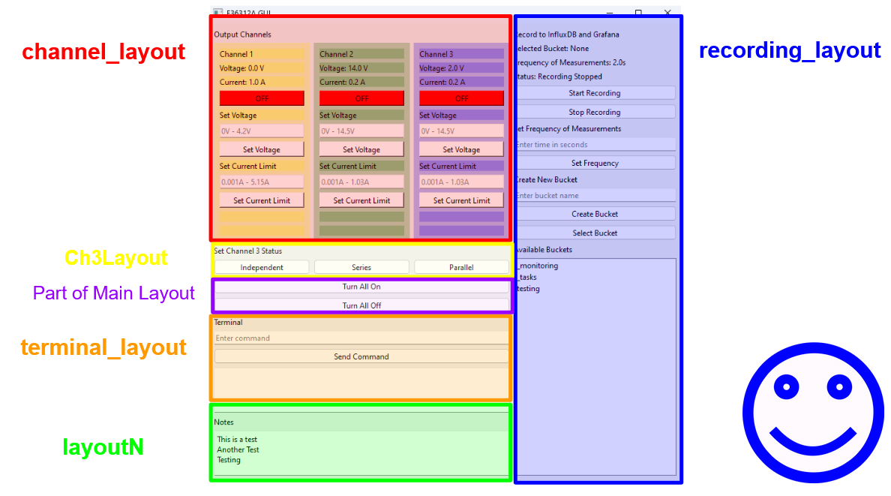

Corresponds to Python code

Warning: Device Resets on Connection if testing is enabled (lines 322-326)

* Power Down
* Voltage/Current setting to default
* Channel 3 Output mode set to Independent
* Briefly turn on all output channels
* Briefly turns on all Data Logger recording parameters
* init_test = x.test(DPS) # Tests device
* if init_test:
* pass
* else:
* print("Error in initiation or test")

Starting: Either GPIB or LAN can be used

* When using LAN, restart devices after communication

### **Improvements for the future**

E36312A GUI locks out CLT, you cannot type in the command line while GUI is running

Needs to be able to communicate with multiple devices; cannot have more than 2 instances running

store/recall - be able to retrieve earlier settings; useful if user runs test()

Loss of connection warning - if device powers off while GUI is open, the connection will be lost and the program has to be re-ran

Minimum recording time to Grafana is 2 seconds -> 100ms room for improvement

* Assuming it is caused by code execution time
* Unlikely to be code issue since all times greater than 2 seconds run properly
* GUI -> .csv buffer -> InFluxDB
* Potential solution to issue

Only channels that are on are recorded

Refresh Grafana when trying to view data

InfluxDB and Grafana Manual below

|

v



### InfluxDB

Automated functions

* Creating Bucket
* Writing to Bucket

Manual Configuration

#### Creating Bucket

Open InfluxDB and Navigate to Up Arrow on the left panel

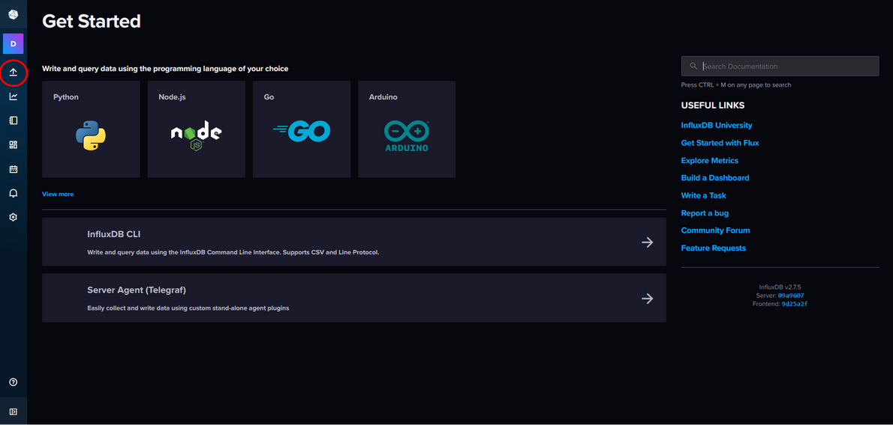

Click Buckets

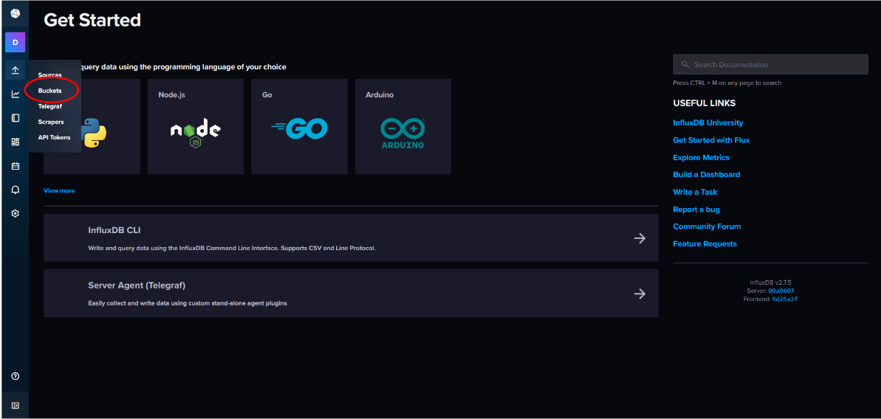

Click Create Bucket in the top right

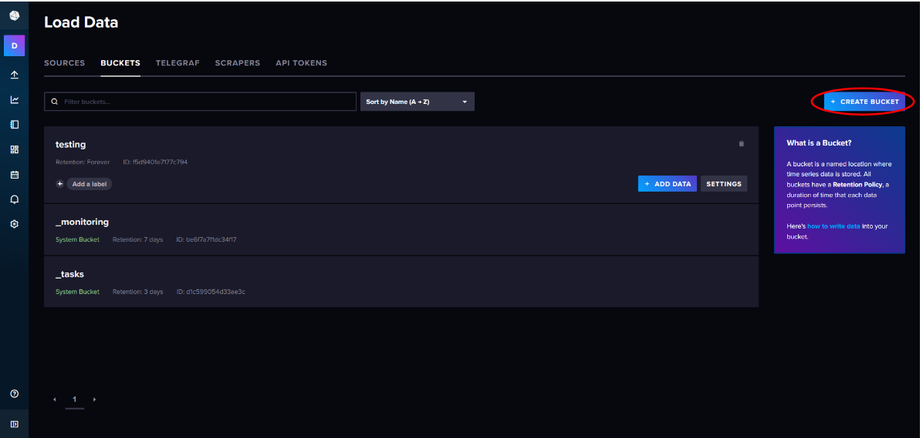

Select if you want the data to never be deleted automatically

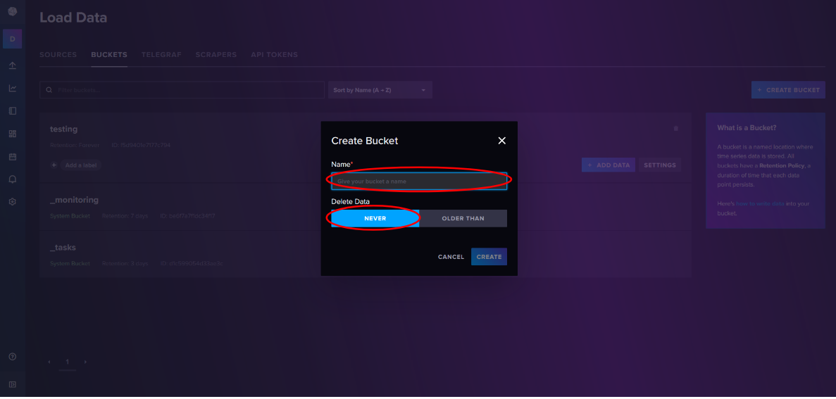

Or if you want the data to be deleted after a set period of time

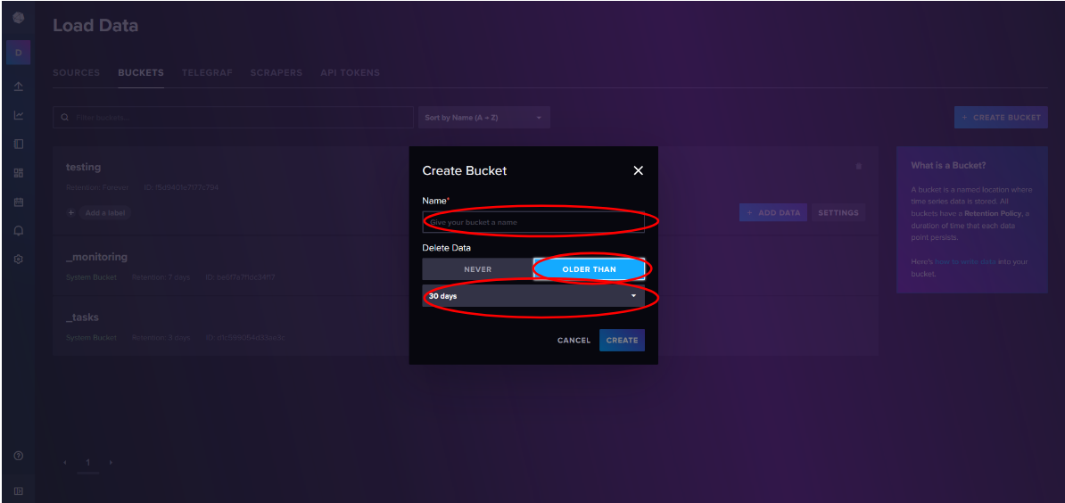

Click Create

#### Writing to Bucket

Open InfluxDB and Navigate to Up Arrow on the left panel



Click Buckets



Click Add Data on the desired bucket

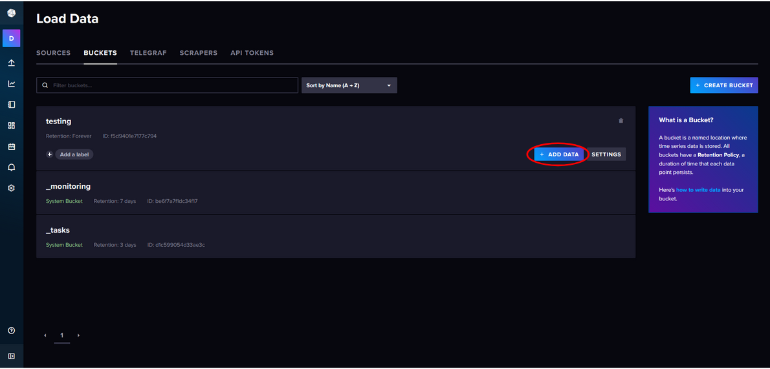

Select Prefered Method, usually CSV or Line Protocol

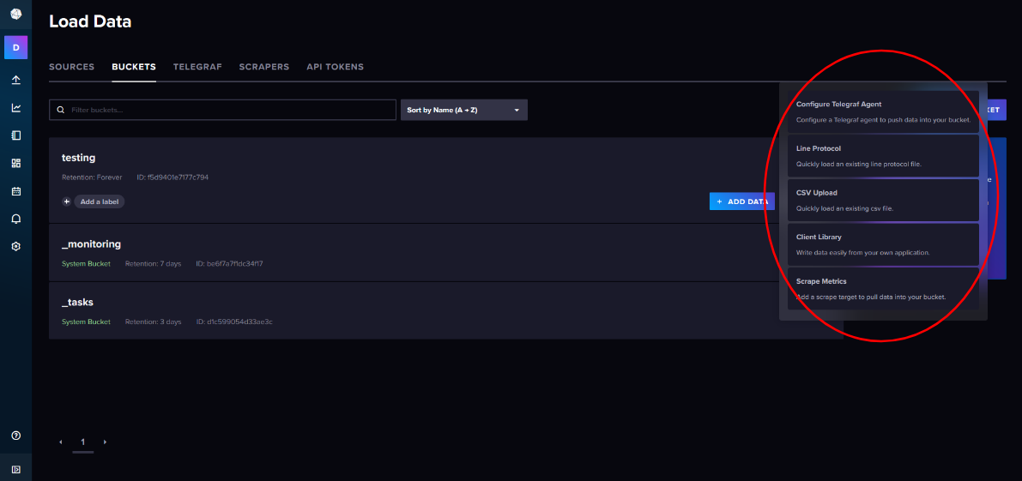

Upload file with data

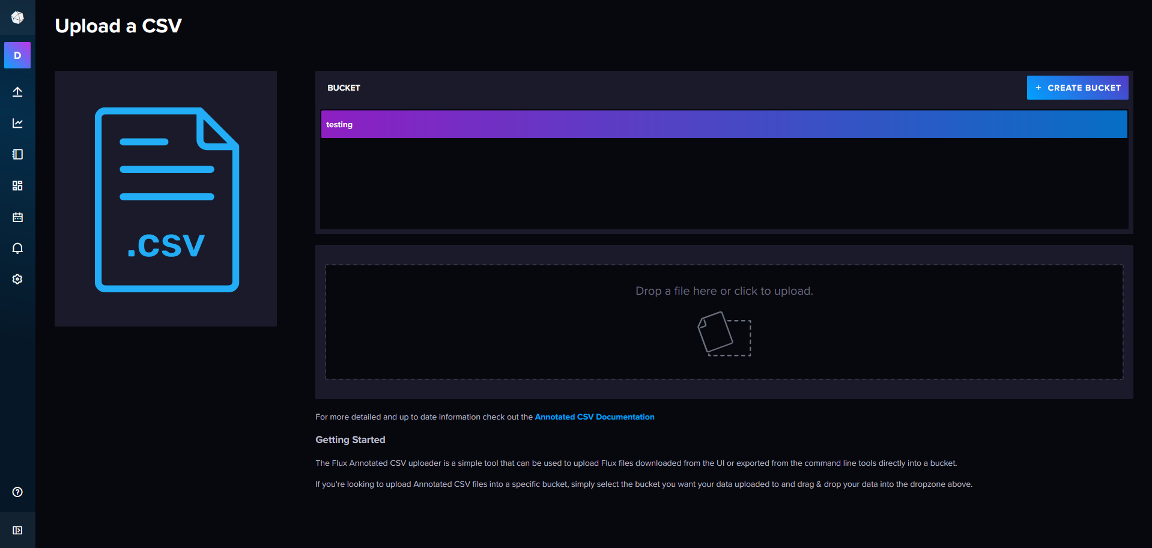

### 

### Grafana

Automated functions

* Plotting of data from a selected bucket

#### Viewing Data

Open Grafana and navigate to Dashboards

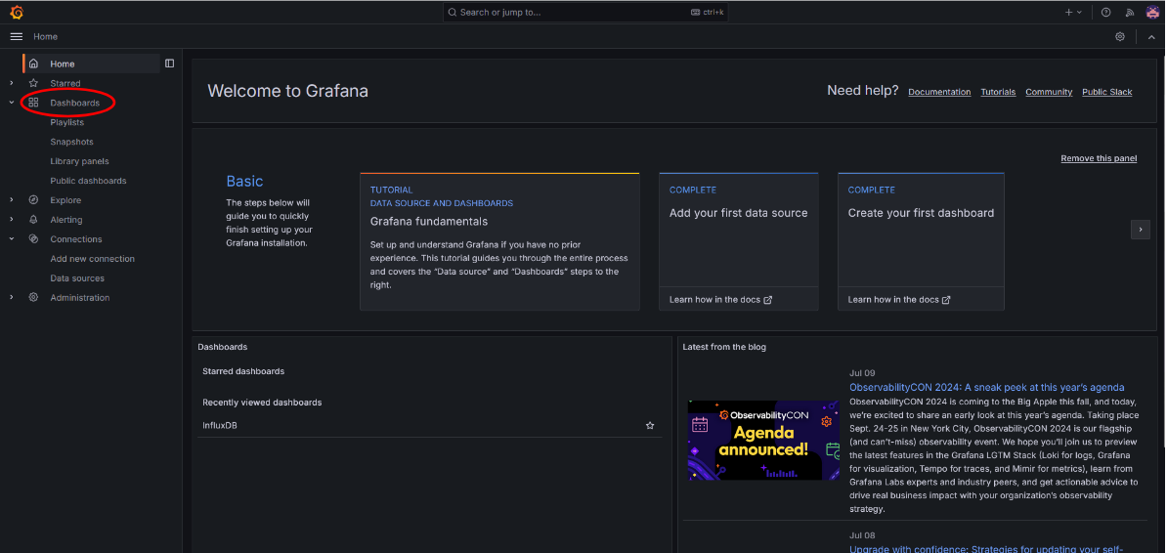

Navigate to InfluxDB

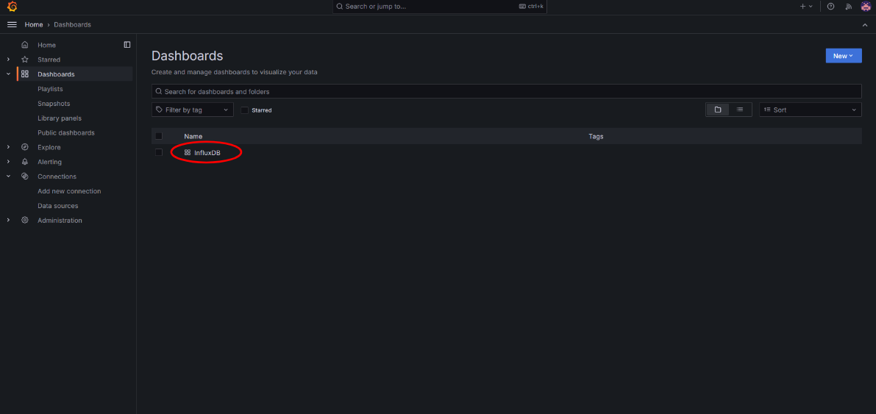

Click three dots on top right of the panel

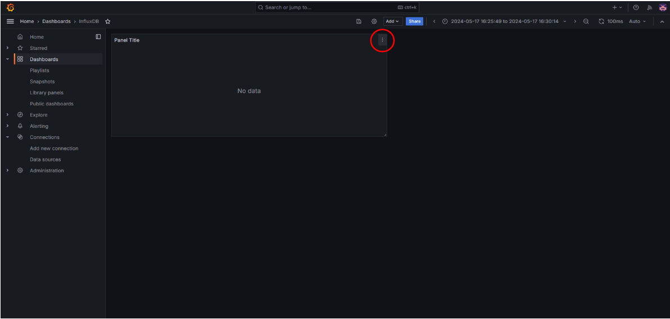

Click Edit

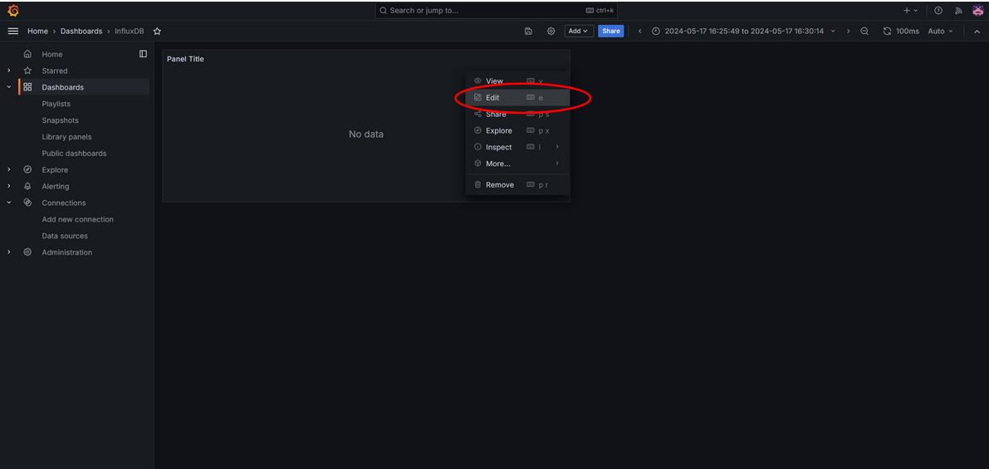

Enter the Bucket you want to display (where the data is stored) and click apply in the top right

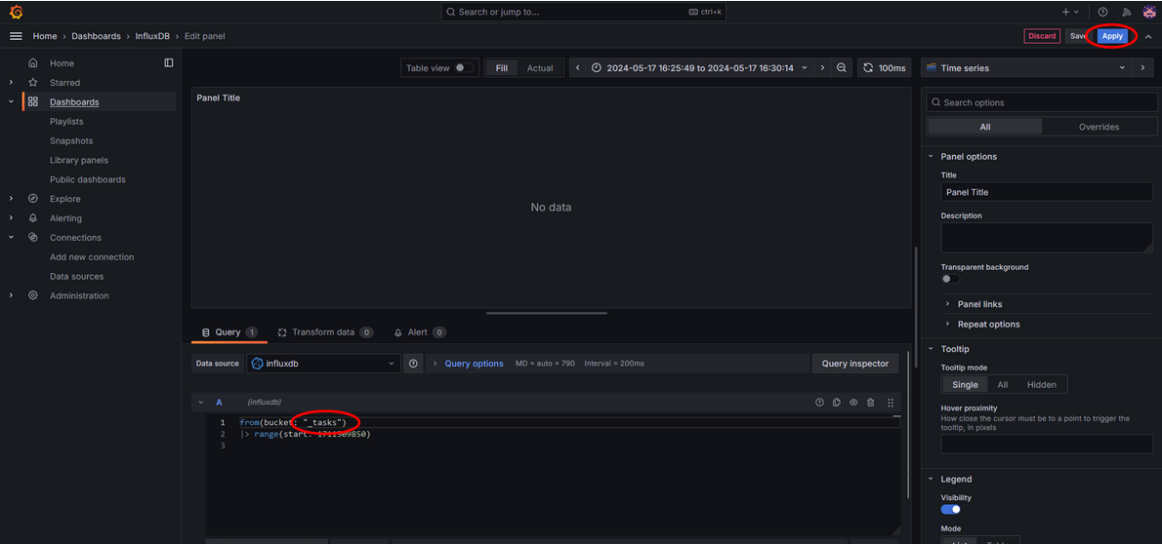

Click Zoom to data on the panel

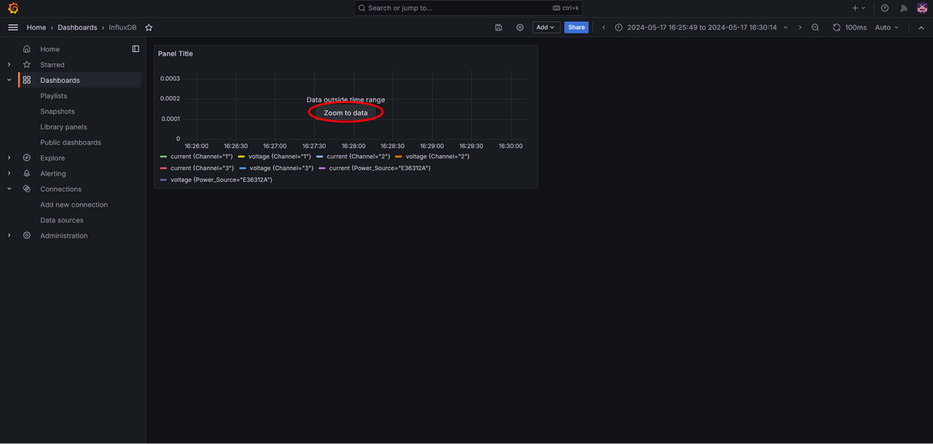

Graph of data will be displayed

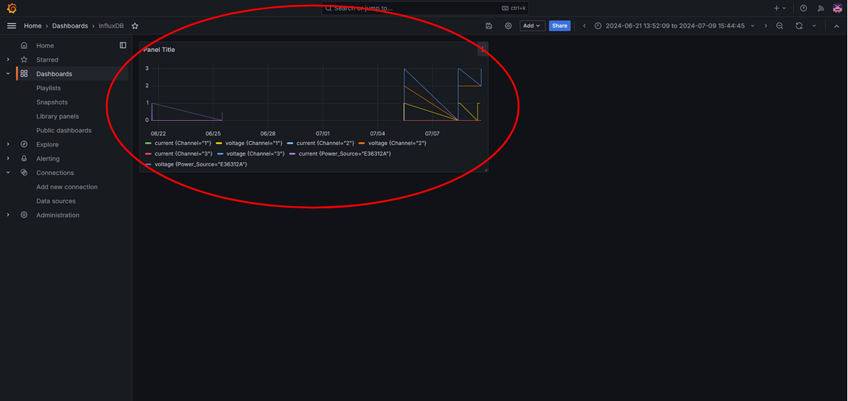

To maximize panel, clicked the three dots then click View

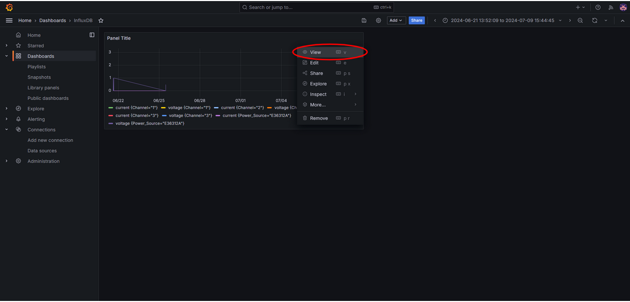

Panel will be Maximized

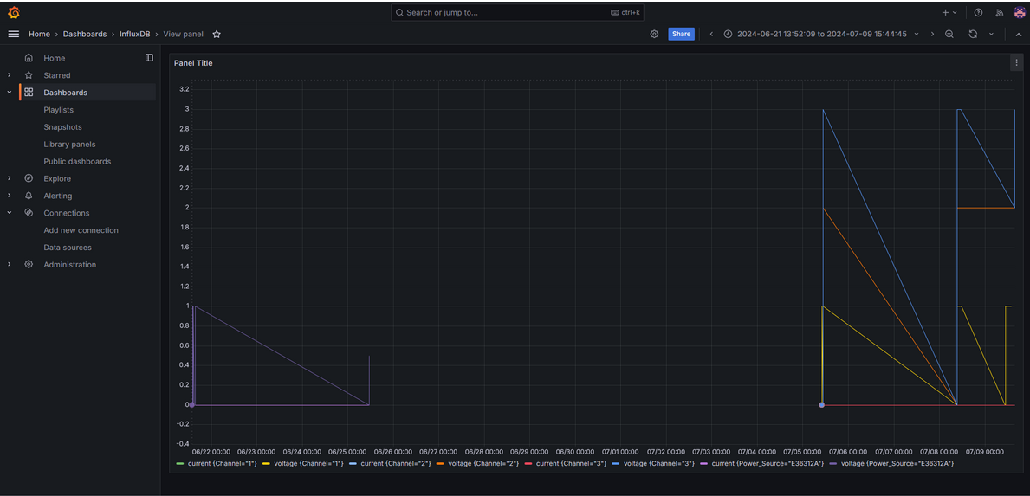

To Zoom Out from the timeframe, click the magnifying glass with a “-” inside it

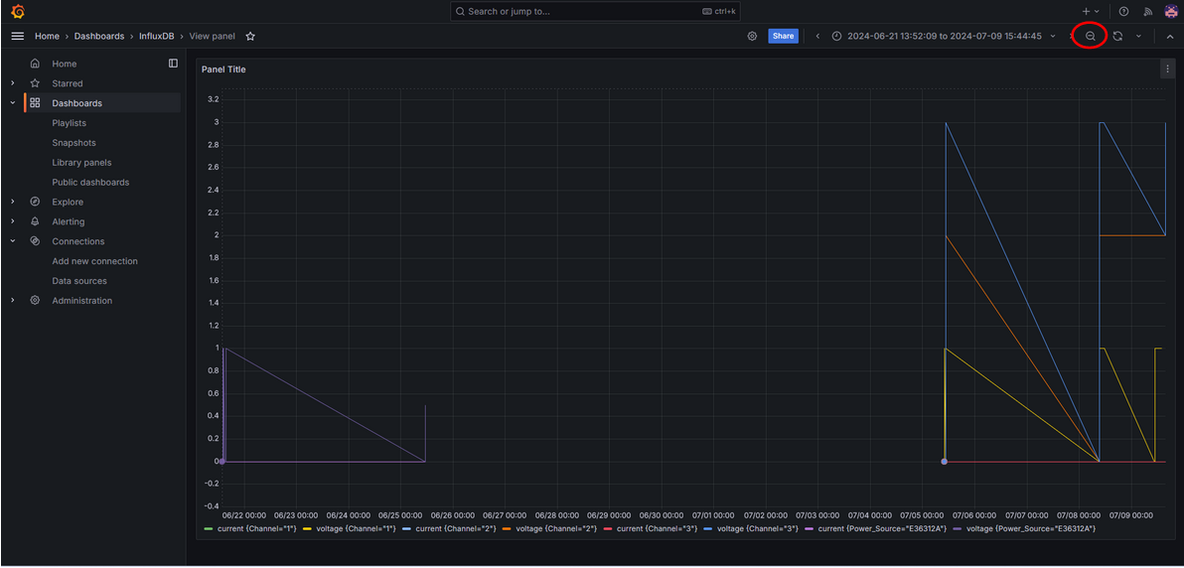

To refresh the graph, click the circular arrows

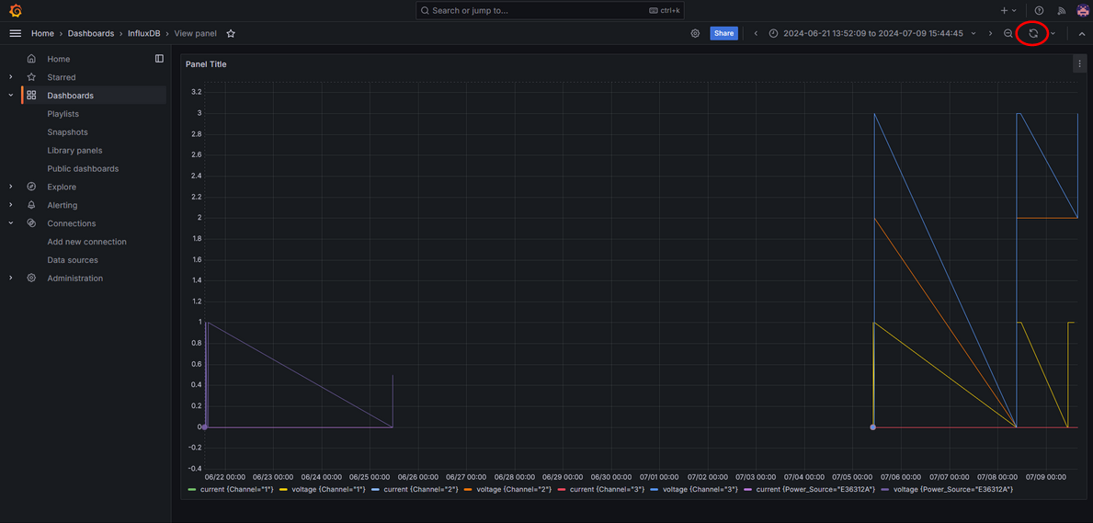

To set auto-refresh, click the downward carrot next to the arrows

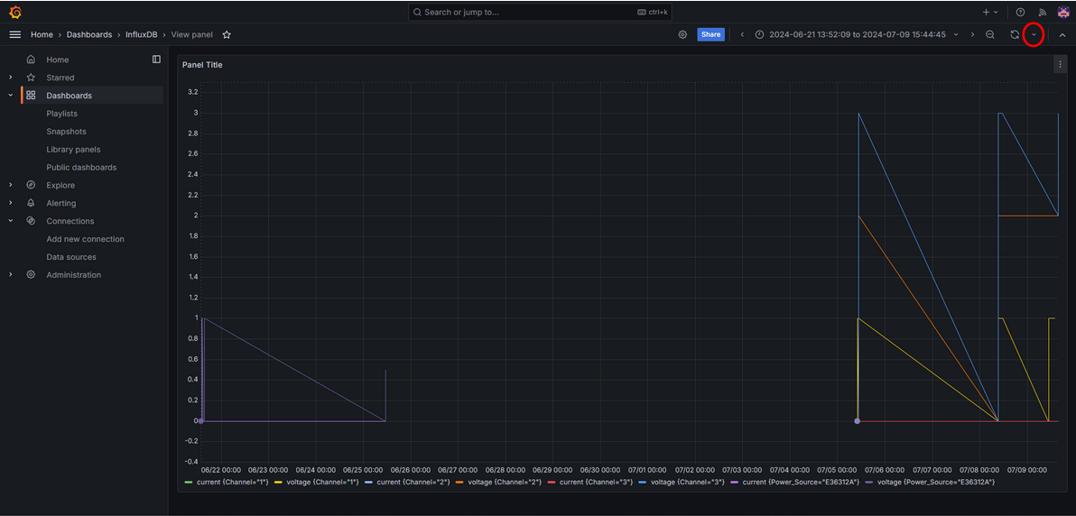

Select the frequency of refreshes

